Commanded to Love
Maundy Thursday
April 9, 2020
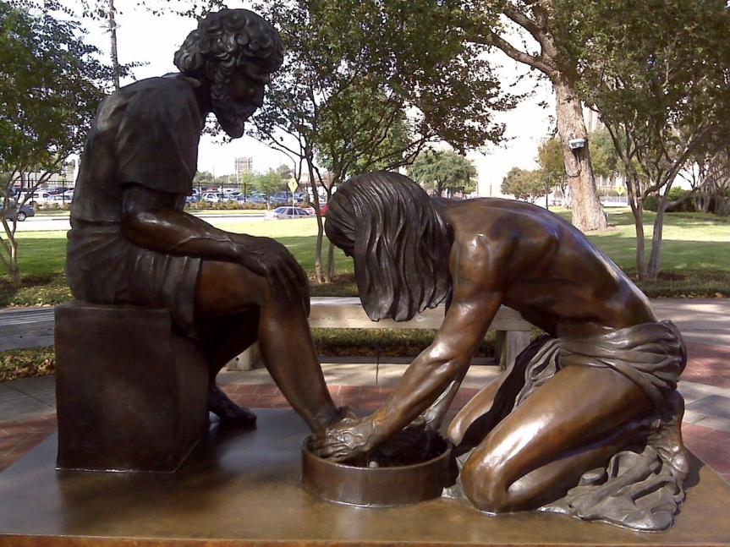
Bishop Michael Rinehart

Holy God, source of all love, on the night of his betrayal, Jesus gave us a new commandment, to love one another as he loves us. Write this commandment in our hearts, and give us the will to serve others as he was the servant of all, your Son, Jesus Christ, our Savior and Lord, who lives and reigns with you and the Holy Spirit, one God, now and forever.

Exodus 12:1-4, (5-10), 11-14 – Passover. Yahweh to Moses and Aaron: This month shall be the beginning of months for you. This day shall be a day of remembrance for you.
Psalm 116:1-2, 12-19 – What shall I give the Lord for his benefit to me? I will lift the cup of salvation, and call upon the name of the Lord. I will pay my vows to the Lord in the presence of all his people.
1 Corinthians 11:23-26 – Paul’s Eucharistic theology: I passed on to you what I received: The words of institution.
John 13:1-17, 31b-35 – Jesus washes the disciples’ feet. A new commandment I give you: Love one another.

Now before the festival of the Passover, Jesus knew that his hour had come to depart from this world and go to the Father. Having loved his own who were in the world, he loved them to the end. ²The devil had already put it into the heart of Judas son of Simon Iscariot to betray him. And during supper ³Jesus, knowing that the Father had given all things into his hands, and that he had come from God and was going to God, ⁴ got up from the table, took off his outer robe, and tied a towel around himself. ⁵ Then he poured water into a basin and began to wash the disciples’ feet and to wipe them with the towel that was tied around him. ⁶ He came to Simon Peter, who said to him, “Lord, are you going to wash my feet?” ⁷ Jesus answered, “You do not know now what I am doing, but later you will understand.” ⁸ Peter said to him, “You will never wash my feet.” Jesus answered, “Unless I wash you, you have no share with me.” ⁹ Simon Peter said to him, “Lord, not my feet only but also my hands and my head!” ¹⁰ Jesus said to him, “One who has bathed does not need to wash, except for the feet, but is entirely clean. And you are clean, though not all of you.” ¹¹ For he knew who was to betray him; for this reason he said, “Not all of you are clean.”

¹² After he had washed their feet, had put on his robe, and had returned to the table, he said to them, “Do you know what I have done to you? ¹³ You call me Teacher and Lord—and you are right, for that is what I am. ¹⁴ So if I, your Lord and Teacher, have washed your feet, you also ought to wash one another’s feet. ¹⁵ For I have set you an example, that you also should do as I have done to you. ¹⁶ Very truly, I tell you, servants are not greater than their master, nor are messengers greater than the one who sent them. ¹⁷ If you know these things, you are blessed if you do them…

“Now the Son of Man has been glorified, and God has been glorified in him. ³² If God has been glorified in him, God will also glorify him in himself and will glorify him at once. ³³ Little children, I am with you only a little longer. You will look for me; and as I said to the Jews so now I say to you, ‘Where I am going, you cannot come.’ ³⁴ I give you a new commandment, that you love one another. Just as I have loved you, you also should love one another. ³⁵ By this everyone will know that you are my disciples, if you have love for one another.”

Commanded to Love

Grace and peace to you from Jesus of Nazareth the crucified Jew, who lived briefly, died violently and rose unexpectedly. To all who live in the shadow of an outbreak, who live in the threat of sickness, and who are “social distancing” or “physical distancing” in a time of community-wide anxiety, may the grace and peace of Christ be with you all.

Tonight is the night in which Jesus was betrayed. This is gut-wrenching stuff. To be betrayed by your inner circle. To be denied by your chief disciple. Jesus is having a bad day. Frankly, a bad week. Given all we’re going through right now, perhaps is good for us to meditate on Jesus’ dark and difficult days before Easter. Here’s how Jesus spent his last day.

- On this night, Jesus instituted the Lord’s Supper.
- On this night, Jesus washed the disciples feet.
- And on this night, Jesus gave his disciples a clear command, recorded in John 13, a passage we read every year on this night:

I give you a new commandment, that you love one another.
Just as I have loved you, you also should love one another.
By this everyone will know that you are my disciples,
if you have love for one another.”

The word “Maundy” comes from the Latin mandatum, which means “command.” It is the word from which we get our word “mandate.”

This is my mandate: Love one another.

None of this should surprise to us.

This carpenter/rabbi was once asked which was the most important commandment. Without missing a beat, he replied with what was most likely the first Bible passage he ever memorized, what every Jewish child memorized, Deuteronomy 6:4-5, the Shema: “Hear O Israel, the Lord your God is one. And you shall love the Lord your God with all your heart, with all your soul, and with all your strength.” He said, “This is the first and greatest commandment. And the second is like onto it: you shall love your neighbor as yourself. On these two rest all the law and the prophets.”

In other words, if you want to know the two most important things in life, they are to love God and to love one another.

He said, on this very night, “By this shall all people know you are my disciples, if you love one another.”

This is the one who taught us not to love just our neighbor, but also love the stranger in our midst (like the Good Samaritan). And not just the stranger but even to love our enemies, and pray for those who persecute us.

Who taught his followers to turn the other cheek, ending the world’s cycle of hatred and violence.

The gospel of John says, “For God so loved the world that he gave his only Son…”

That’s John 3:16. A lot of people have that memorized, but not as many people know 1 John 3:16: “We know love by this, that he laid down his life for us—and we ought to lay down our lives for one another.”

These are words we need to hear now more than ever.

This theology was so strong that John also said this in 1 John 4:7-8: “Beloved, let us love one another, for love is of God, and everyone that loves is born of God and knows God. Whoever does not love, does not know God, for God is love.”

This understanding of the centrality of love in the gospel is present in Paul’s writings too. In his most famous chapter, 1 Corinthians 13, the chapter that is read it every wedding even though it’s not about marriage, Paul says,

If I speak in the tongues of mortals and of angels, but do not have love, I am a noisy gong or a clanging cymbal.

And if I have prophetic powers, and understand all mysteries and all knowledge…

if I have all faith, so as to remove mountains, but do not have love, I am nothing.

If I give away all my possessions, and even make the ultimate sacrifice and give my life, but do not have love, I gain nothing.

At the end of time all things will pass away, but only three things will endure: faith, hope and love, but the greatest of these is… love.

This is the Christian faith, that there is nothing in all creation that can separate you from this love of God as seen in Christ.

And so, on this night, Jesus said, “A new commandment I give you: Love one another, just as I have loved you.”

But wait a second, that’s not a new commandment. Jesus learned as a child. It’s all over the Hebrew Bible. There’s nothing new about loving one another. The new part of this is “as I have loved you.”

Washing Feet

And how did Jesus love us?

He loved us by wrapping a towel around his waist and washing his disciples feet, the job of the lowly servant. And when they barked at this, he said I do this to set an example for you, as I’ve done for you so you should do for others. Love means becoming a servant of all people. It means in his time of crisis, Jesus tended to the needs of others. It means in our time of trial tending to the needs of others. That’s how Jesus loved us.

Giving himself to eat and drink.

And how did Jesus love us?

He loved us by giving his disciples bread, said take and eat, do this in remembrance of me. He gave them wine, said take and drink, for the forgiveness of your sins. Before they betrayed and denied him, he already forgave. That’s how Jesus loved us.

Most of us are not eating bread and drinking wine on this night. Even this you do out of love, not to protect yourself, but to protect others, the most vulnerable. Even Jesus fasted from this night on, saying, “Truly I tell you, I will not drink again of the fruit of the vine until I drink it with you in the kingdom of heaven.” That’s how Jesus loved us. Love is sacrificial.

Giving his life

And how did Jesus love us?

By teaching us the meaning of love. He said, “Greater love has no one than this, than you lay down your life for your friends.” Love is not a greeting card sentiment. It is a whole life commitment. Love is not a feeling. It is a commitment to act on behalf of the beloved, in the beloved’s best interests, regardless of the consequences.

He loved us by giving his life on the cross.

That’s the kind of love that God has for you. It is invincible. It is an everlasting love, that is even stronger than the grave. It’s a love that will sustain during times of uncertainty. It’s a love you can share and never run out.

God’s grace to you this Holy Week.

